1. What is true for Chain of Responsibility pattern?

* Client initiates a request to one of several objects and it specifies which one of them should handle it.
* **Client initiates a request to one of several objects and it doesn’t specify which one of them should handle it.**
* Client initiates a request and passes it to more objects and it specifies which one of them should handle it.
* None of the options

1. The following high-level GoF description defines the ____________ design pattern

The intention of the pattern is to *avoid coupling the sender of a request to its receiver by giving more than one object a chance to handle the request. Client initiates a request and passes it to a handler. Each handler performs its processing logic, and then potentially passes the processing request onto the next link (i.e. handler).*

* Observer
* **Chain of Responsibility**
* Visitor
* Command

1. What Design Pattern is used in the following UML diagram?

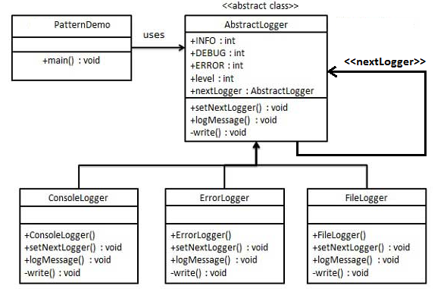

* Composite
* Template Method
* Strategy
* **Chain of Responsibility**

1. What is true for the following Chain of Responsibility pattern UML class diagram?

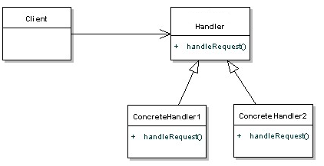

* It is valid UML class diagram
* *handleRequest* method should take next handler as parameter
* **There is missing reference to a next handler**
* Handler should be renamed to Element

1. The following implementation is responsibility of which participant of Chain of Responsibility pattern ?

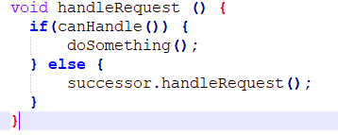

* Handler
* **Concrete Handler**
* Client
* Request

1. The _______________ handles requests it is responsible for, otherwise forwards requests to successor

* Handler
* **Concrete Handler**
* Client
* Request

1. What Design Pattern is most probably used in the following UML diagram?

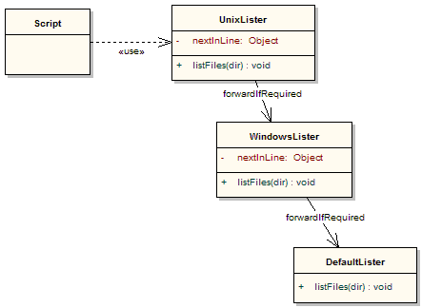

* Command
* **Chain of Responsibility**
* Observer
* Strategy

1. What Design Pattern is used in the following UML diagram?

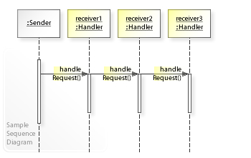

* Command
* **Chain of Responsibility**
* Observer
* Strategy